Openbook The App

# Abstract

This study includes an overview of creating a Library Management System, as well as the conditions that must be satisfied for the system to be effective. This paper explores a Library Management System and the conditions that must be satisfied for it to be effective. This app will have a database to search books and texts and will have downloadable pdf for the majority.

# Introduction

This app is based on the idea of having libraries across the world that could be accessed everywhere, in a way that would publish online, to advertise the object by letting it be free for a while, so that more people could be interested in the content. For this idea to be created a variety of elements must be addressed to undertake its feasibility study, for example:

* The cost of building the app;
* The time necessary to develop the app;
* The skills and expertise required to construct the app;
* The amount of people that are necessary for the study;
* Which texts and books will be added to the app;
* The laws of the countries regarding the app;
* The market demand for the app are all factors to consider.

The functional and non-functional needs of the system must be addressed while doing a requirement analysis. The functional requirements define what the system should perform, and they are:

* Allow a moderator to add and remove new members;
* Allow the user to search for books based on title, publication date, author, and find their location in the library;
* Users can request, reserve, or renew a book;
* Moderators or original book creators can add and manage the book;
* The system should notify the user and moderator about the overdue books;
* The system calculates the fine for overdue books on their return;
* Creation of Pdf file of the book and link to download it;
* Interface for moderators and original book creators to adjust the time range that the book will be available for free;
* Interface for reading pdf.

Whereas the non-functional requirements describe how the system should work, and they are:

* The usability;
* The accuracy;
* The maintainability;

Next step is to create a test plan for the system for its usability, accuracy, and maintainability. This plan will be essential for the V&V Model that will be used after the implementation phase.

# Main Scenario

The main Scenario will be the app by itself, that will be available for both IOS and Android users. The readers will download the app, register themselves and add their reading preferences. After that they will be directed to a home page that will show some options for reading that match that person’s interests. The user will be able to use a search engine to see if any desired book is available or the user can just choose one of the given options. The user will then proceed for a page of the book and then download it in its cellphone or read it in the app

# Sub-Scenario

* Authentication Management
* User Management;
* Tittle Management;
* Search Management;
* Download Management;

Authentication Management:

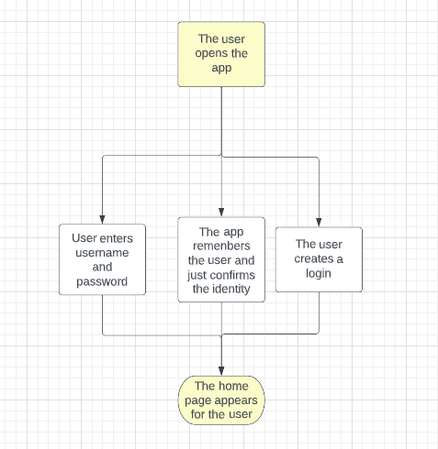

If creation of login:

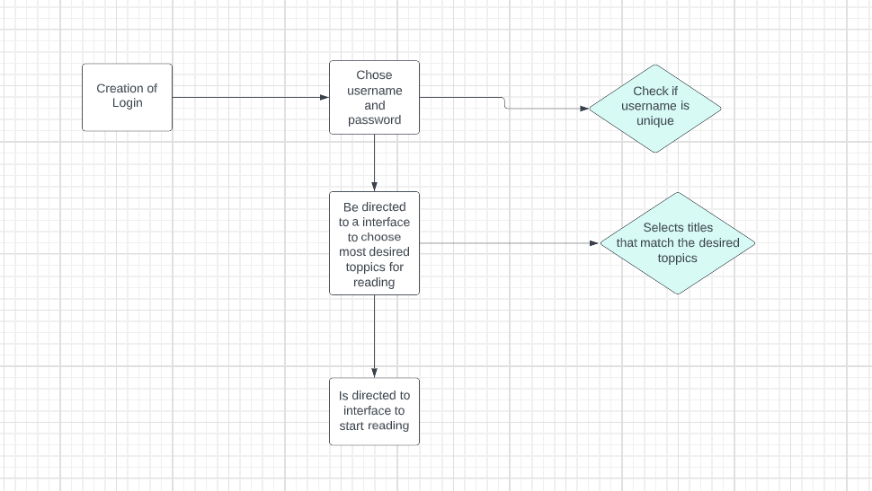

User Management:

* Account Management:

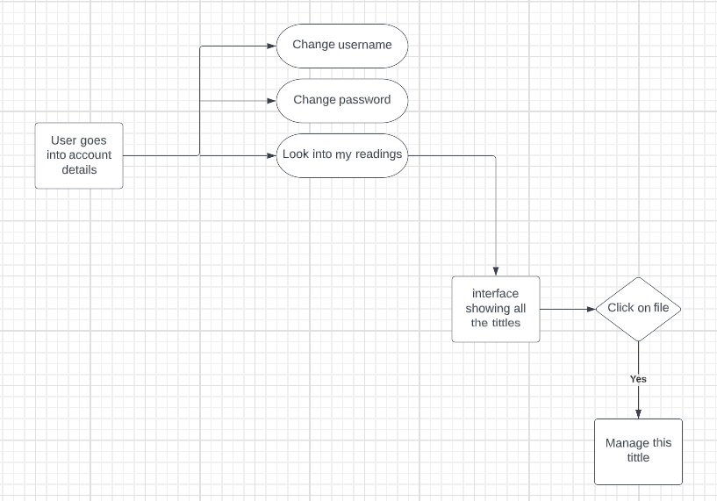

Tittle management:

Search management:

Download Management:

